**225-[LX]-Lab - Introduction to Amazon Linux AMI**

**Accessing the AWS Management Console :**

**1.At the top of these instructions, choose Start Lab to launch your lab.**

**2.Wait until lab status ready.**

**3.At the top choose AWS.**

**4.AWS console is now opened.**

**Task 1: Use SSH to connect to an Amazon Linux EC2 instance: Using SSH to Connect**

1. **Go to EC2 dashboard , there is already running a instance with name command host**
2. **Download PPK key with name labuser.ppk while from workbench top right under details.**
3. **Select the Details on workbench top right corner and select SHOW , then download ppkkey.**
4. **Connect the EC2 instance**
5. **Copy Public IP and paste it to Notepad.**
6. **Now Paste Public IPv4 address of command host into putty and select connection then**
7. **SSH then Auth and go into credential part and upload Labuser.ppk there**.

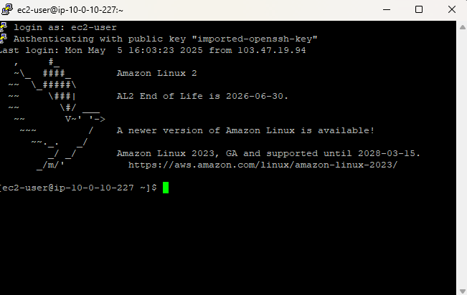

**Task 2: Exercise - Explore the Linux man pages:**

1. **Now enter man man in the command prompt.**
2. **Now press Q for quit , end lab and submit .**

